**WHAT IS THE LANGUAGE OF SWITZERLAND**

**https://24x7offshoring.com/**

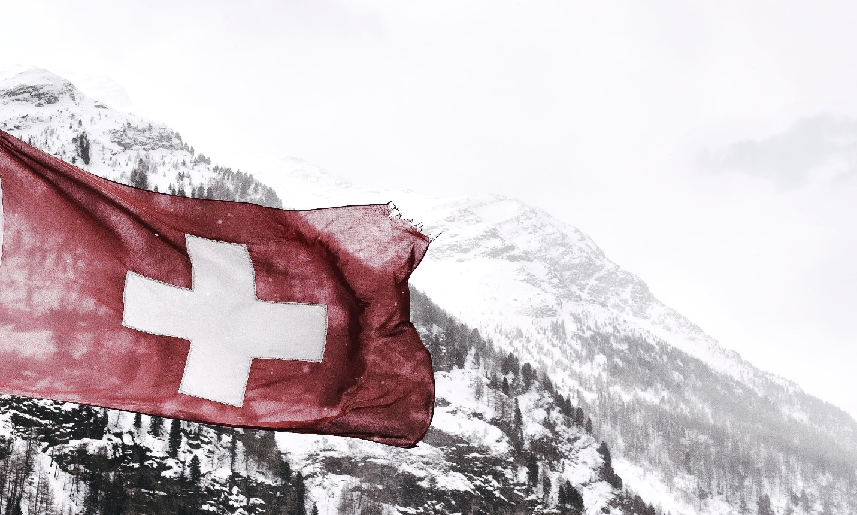 [**http://24x7outsourcing.com/**](http://24x7outsourcing.com/)

Switzerland is an entrancing country for some reasons.

Did you realize that it has topped the Global Innovation Index for ten successive years?

Or on the other hand that it is home to 7,000 lakes? With regards to the number of dialects are spoken in Switzerland, the nation likewise gives a fascinating examination.

As an interpretation office, 24x7offshoring.com has been working with the dialects expressed in Switzerland for above and beyond 10 years.

What language is spoken in Switzerland? Peruse on to discover! You can likewise investigate our interpretation administrations to discover more about our phonetic skill.

**What do they talk in Switzerland?**

Indeed, there isn't only one authority language spoken in Switzerland, however four! German, French, Italian and Romansh are all important for the Switzerland language map.

Some 62.6% of the Swiss populace communicates in German; 22.9% communicate in French; 8.2% communicate in Italian; and 0.5% speak Romansh.

In this article, we'll take a gander at every language expressed in Switzerland thusly, just as the set of experiences behind them.

We should make a plunge!

**The Official Languages of Switzerland**

**What are the dialects verbally expressed in Switzerland?**

As we referenced over, the authority dialects of Switzerland incorporate Swiss German, French, Italian and Romansh. We should investigate every one of them.

**Swiss German**

What language is generally spoken in Switzerland?

The most consistently discussed the four authority dialects of Switzerland is German. This is part between the 58.5% of the populace who speak Swiss German at home or potentially the 11.1% who speak Standard German.

Swiss German is generally spoken across North Western, Eastern and Central Switzerland, just as the majority of the Swiss Plateau and the bigger piece of the Swiss Alps.

24x7offshoring.com has been giving English to German interpretation administrations to serve customers there for as far back as 13 years.

Composed Swiss German is unfathomably like Standard German, however with a couple of outstanding contrasts.

Swiss German, for instance, doesn't utilize the eszett (ß) yet rather utilizes a twofold s (ss).

There are, obviously, contrasts in articulation and especially with regards to local accents and tongues.

17 of Switzerland's cantons have German as their lone authority language, implying that it is a significant language of both business and day by day life in Switzerland.

**Swiss French**

French is spoken by some 22.9% of the nation's populace, implying that it is one more of the fundamental dialects of Switzerland.

It is spoken in the cantons of Geneva, Vaud, Neuchâtel and Jura. French speakers are likewise present in the larger part German-talking canton of Bern and in Valais and Fribourg, the two of which are home to principally French speakers.

On the whole, the French-talking some portion of Switzerland is known as Romandy. Romandy is home to an aggregate of 1.9 million Swiss residents.

**Swiss Italian**

Italian is one more of the four authority dialects of Switzerland, however the quantity of speakers has been in decrease in ongoing many years.

The level of Swiss Italian speakers has dropped from 12% of the populace during the 1970s to around 8% today. A decrease in the quantity of individuals moving from Italy to Switzerland has been at the core of this phonetic decay.

**WHAT IS THE LANGUAGE OF SWITZERLAND**

**https://24x7offshoring.com/**

**http://24x7outsourcing.com/**